CHAPTER 4
Trees
4.1 (a) A.
(b) G, H, I, L, M, and K.
4.2 For node B:
(a) A.
(b) D and E.
(c) C.
(d) 1.
(e) 3.
4.3 4.
4.4 There are N nodes. Each node has two links, so there are 2N links. Each node but the root has one incoming link from its parent, which accounts for N − 1 links. The rest are null.
4.5 Proof is by induction. The theorem is trivially true for h = 0. Assume true for h = 1,2, . . . ,k. A tree of height k + 1 can have two subtrees of height at most k. These can have at most 2^{k + 1}−1 nodes each by the induction hypothesis. These 2^{k + 2}−2 nodes plus the root prove the theorem for height k + 1 and hence for all heights.
4.6 This can be shown by induction. Alternatively, let N = number of nodes, F = number of full nodes, L = number of leaves, and H = number of half nodes (nodes with one child). Clearly, N = F + H + L. Further, 2F + H = N − 1 (see Exercise 4.4). Subtracting yields L − F = 1.
4.7 This can be shown by induction. In a tree with no nodes, the sum is zero, and in a one-node tree, the root is a leaf at depth zero, so the claim is true. Suppose the theorem is true for all trees with at most k nodes. Consider any tree with k + 1 nodes. Such a tree consists of an i node left subtree and a k − i node right subtree. By the inductive hypothesis, the sum for the left subtree leaves is at most one with respect to the left tree root. Because all leaves are one deeper with respect to the original tree than with respect to the subtree, the sum is at most 1/2 with respect to the root. Similar logic implies that the sum for leaves in the right subtree is at most 1/2, proving the theorem. The equality is true if and only if there are no nodes with one child. If there is a node with one child, the equality cannot be true because adding the second child would increase the sum to higher than 1. If no nodes have one child, then we can find and remove two sibling leaves, creating a new tree. It is easy to see that this new tree has the same sum as the old. Applying this step repeatedly, we arrive at a single node, whose sum is 1. Thus the original tree had sum 1.
4.8 (a) - * * a b + c d e.
(b) ( ( a * b ) * ( c + d ) ) - e.
(c) a b * c d + * e -.
4.9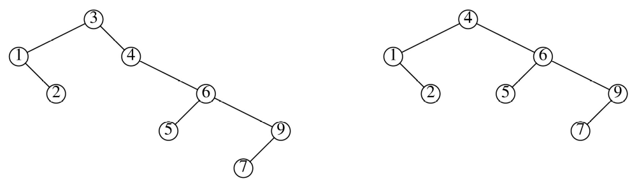
4.10 (a) Both values are 0.
(b) The root contributes (N − 2)/N full nodes on average, because the root is full as long as it does
not contain the largest or smallest item. The remainder of the equation is the expected contribution
of the subtrees.
(d) The average number of leaves is (N + 1)/3.

4.11 The Set class is the BinarySearchTree class with the two classes const_iterator and iterator imbedded
into it as well as a new data member (int Size; ). In the first two code examples are classes for both
iterators with ++ implemented. The third code example shows the new insert and begin member
functions, while the fourth example shows the modified BinaryNode struct. For a fully operational
Set, −− would be implemented along with the functions contains and erase.
(a)
class const_iterator
{
public:
const_iterator( ) : current( NULL ) { }
const Comparable & operator* ( ) const { return retrieve( ); }
const_iterator & operator++ ( )
{
BinaryNode<Comparable> *t ;
if (current->right)
{
t= current->right;
while (t->left != NULL)
t = t-> left;
current = t;
}
else
{
t = current->parent;
cout<<"first parent is " <<t->element<<endl;
while (t && t-> element < current-> element)
t = t->parent;
current = t;
}
return *this;
}

const_iterator operator++ ( int )
{
const_iterator old = *this;
++( *this );
return old;
}

bool operator== ( const const_iterator & rhs ) const
{ return current == rhs.current; }

bool operator!= ( const const_iterator & rhs ) const
{ return !( *this == rhs ); }
protected:
BinaryNode <Comparable> *current;
Comparable & retrieve( ) const
{ return current->element; }

const_iterator( BinaryNode<Comparable> *p ) : current( p ) { }

friend class Set;
};
(b)
class iterator : public const_iterator
{
public:
iterator( ) { }
Comparable & operator* ( )
{ return const_iterator ::retrieve( ); }
const Comparable & operator* ( ) const
{ return const_iterator ::operator*( ); }
iterator & operator++ ( )
{
BinaryNode<Comparable> *t ;
if (current->right)
{
t= current->right;
while (t->left != NULL)
t = t-> left;
current = t;
}
else
{
t = current->parent;
cout<<"first parent is " <<t->element<<endl;
while (t && t-> element < current-> element)
t = t->parent;
current = t;
}
return *this;
}
iterator operator++ ( int )
{
const_iterator old = *this;
++( *this );
return old;
}
iterator( BinaryNode<Comparable> *p ) : const_iterator( p ) { }
friend class Set;
};
(c)
//This is the public insert
iterator insert( const Comparable & x)
{ Size++; return insert (x, root, root);}

// This is private
iterator insert( const Comparable & x, BinaryNode<Comparable> * & t,
BinaryNode<Comparable> * p ) //parent node
{
if( t == NULL )
{
t = new BinaryNode<Comparable>( x, NULL, NULL, p );
return iterator (t);
}
else if( x < t->element )
return (insert( x, t->left, t ));
else if( t->element < x )
return(insert( x, t->right, t ));
return iterator (t) ;
}

// This is the public begin (aka minimum element)
iterator begin()
{
BinaryNode<Comparable> *t = root;
while (t->left)
t = t->left;
return iterator (t);
}

(d)
template<typename Comparable>
struct BinaryNode
{
Comparable element;
BinaryNode *left;
BinaryNode *right;
BinaryNode *parent;
BinaryNode() { left = NULL, right = NULL; parent = NULL;}
BinaryNode( const Comparable & theElement)
{ element = theElement; left = NULL; right = NULL; parent = NULL;}
BinaryNode( const Comparable & theElement, BinaryNode *lt, BinaryNode *rt ,
BinaryNode *pt): element( theElement ), left( lt ), right( rt ), parent(pt) { }
};

4.12
template <typename KeyType, typename ValueType >
class Map
{
public:
Map(int size = 10)
{ map(size); }
void resize(int size)
{map.resize(size);}
int size()
{return map.size();}
bool empty()
{return map.empty();}
void insert(const pair<KeyType,ValueType> & p)
{map.insert(p);}
iterator find(const KeyType & key) const
{
for (iterator itr = map.begin(); itr != map.end(); itr++)
if (itr->first == key)
return itr;
return map.end();
}
ValueType & operator[](const KeyType &key)
{
iterator itr = map.find(key);
if(itr != map.end())
return itr->second;
else
map.insert(make_pair(key,0));
}
int erase(const pair<KeyType, ValueType> & p)
{return map.erase(p);}
iterator erase( const iterator & itr)
{return map.erase(iter);}
iterator end()
{return map.end();}
iterator begin()
{return map.begin();}

private:
set<pair<KeyType, ValueType>> map;
};

4.13
#include <iostream>
using namespace std;

template<typename Comparable>
struct BinaryNode
{
Comparable element;
BinaryNode *left;
BinaryNode *right;
BinaryNode *next; // next node by comparison
BinaryNode *prev; // prev node by comparison
BinaryNode() { left = nullptr; right = nullptr; next = nullptr; prev = nullptr;}
BinaryNode( const Comparable & theElement) { element = theElement; left = nullptr;
right = nullptr; next = nullptr; prev = nullptr;}
BinaryNode( const Comparable & theElement, BinaryNode *lt, BinaryNode *rt ,
BinaryNode *pr, BinaryNode *nx )
: element( theElement ), left( lt ), right( rt ), next(nx), prev(pr) { }
};

template<typename Comparable>
class Set
{
public:

class const_iterator
{
public:
const_iterator( ) { current = nullptr;}
const_iterator(BinaryNode<Comparable> *p ) { current = p; }
const Comparable & operator* ( ) const { return retrieve( ); }
const_iterator & operator++ ( )
{
current = current->next;
return *this;
}
const_iterator & operator-- ( )
{
current = current->prev;
return *this;
}
const_iterator operator++ ( int )
{
const_iterator old = *this;
++( *this );
return old;
}

bool operator== ( const const_iterator & rhs ) const
{ return current == rhs.current; }
bool operator!= ( const const_iterator & rhs ) const
{ return !( *this == rhs ); }

protected:
BinaryNode<Comparable> *current;
Comparable & retrieve( ) const
{ return current->element; }

friend class Set;
};

class iterator : public const_iterator
{
public:
iterator( ):const_iterator()
{current = nullptr; }
iterator(BinaryNode<Comparable> *p )
{current = p;}
Comparable & operator* ( )
{ return const_iterator ::retrieve( ); }

const Comparable & operator* ( ) const
{ return const_iterator ::operator*( ); }

iterator & operator++ ( )
{
const_iterator::current = const_iterator::curent->next;
return *this;
}
iterator operator++ ( int )
{
iterator old = *this;
++( *this );
return old;
}

friend class Set;
};

Set() {root = nullptr;
smallest = new BinaryNode<Comparable>();
largest = new BinaryNode<Comparable>();
smallest->next = largest;
smallest->prev = nullptr;
largest->next = nullptr;
largest->prev = smallest;
Size = 0;
}
iterator insert(const Comparable & x)
{
Size++;
return insert(x,root,smallest,largest);
}
iterator begin()
{return iterator(smallest->next);}
iterator end()
{return iterator(largest);}
private:
BinaryNode<Comparable> *root;
BinaryNode<Comparable> *smallest;
BinaryNode<Comparable> *largest;
int Size;
iterator insert(const Comparable & x, BinaryNode<Comparable>* & t, BinaryNode<Comparable>*small, BinaryNode<Comparable>*large)
{
if (t == nullptr)
{
t = new BinaryNode<Comparable>(x,nullptr,nullptr, small, large);
small->next = t;
large->prev = t;
return iterator(t);
}
else if (x < t->element)
return (insert(x, t->left , small, t));
else if (x > t->element)
return (insert(x, t->right, t, large));
return iterator(t);
}
};

4.14 (a) Keep a bit array B. If i is in the tree, then B[i] is true; otherwise, it is false. Repeatedly generate random integers until an unused one is found. If there are N elements already in the tree, then M − N are not, and the probability of finding one of these is (M − N)/M. Thus the expected number of trials is M/(M − N) = α/(α −1).
(b) To find an element that is in the tree, repeatedly generate random integers until an already-used integer is found. The probability of finding one is N/M, so the expected number of trials is M/N = α.

(c) The total cost for one insert and one delete is alpha/(α − 1) + α = 1 + α + 1/(α − 1). Setting alpha = 2 minimizes this cost.

4.15 Below is code for both b and c (b is commented out) as well as a function to compute the balance sum of the balance of all the nodes.
BinaryNode<Comparable> * findMax(BinaryNode<Comparable> * t)
{
if (t == nullptr || t->right == nullptr)
return t;
else return findMax(t->right);
}
BinaryNode<Comparable> * findMin(BinaryNode<Comparable> * t)
{
if (t == nullptr || t->left == nullptr)
return t;
else return findMin(t->left);
}
void remove( const Comparable & x, BinaryNode * & t )
{
// static int counter = 0; // used to alternate removal methods
if( t == nullptr )
return; // Item not found; do nothing
if( x < t->element )
remove( x, t->left );
else if( t->element < x )
remove( x, t->right );
else if( t->left != nullptr && t->right != nullptr ) // Two children
{
if (rand()%2) // used to randomly determine which removal method to use
// if (counter++ % 2)
{
t->element = findMin( t->right )->element;
remove( t->element, t->right );
}
else
{
t->element = findMax( t->left )->element;
remove( t->element, t->left);
}
//counter %=2;
}
else
{
BinaryNode *oldNode = t;
t = ( t->left != nullptr ) ? t->left : t->right;
delete oldNode;
}
}
};
int height(BinaryNode<Comparable> * t)
{
if (t == nullptr)
return 0;
else
return 1+ max(height(t->left),height(t->right));
}

int balance(BinaryNode<Comparable> * t>)
{
if (t == nullptr)
return 0;
else
return abs(height(t->right)-height(t->right)) + balance(t->right)
+ balance(t->right);
}
4.16 The binary node will be contain a field bool deleted, (initially set to false). When the ++
and – must be changed to bypass any node whose deleted is true. The insert must also be modified to skip any deleted nodes on insert and should allow reinsertion by just flipping the deleted bit. For delete, the node is found, and then its deleted bit is set to true.

BinaryNode<Comparable> * findMax(BinaryNode<Comparable> * t)
{
if (t == nullptr) return nullptr;
BinaryNode<Comparable> * maxptr = findMax(t->right);
if (maxptr != nullptr)
return maxptr;
else if (t->deleted == true)
return findMax(t->left);
else
return t;
}

4.17 Let the internal path length of a tree with n nodes, be the sum of all the depths of all the nodes in the tree and denoted C_{n} . Then the average depth would be C_{n}/ N. Consider a binary search tree with keys {1, 2, … n}. If the tree is rooted at node i, then there are i -1 nodes left of the root and n – i nodes to the right of the root. Hence to compute the average over all possible roots we have
C_{n} = n – 1 + [(C₀ + C_{n-1}) + (C₁ + C_{n-2}) + (C₂ + C_{n-3}) + … + (C_{n-1} + C₀)]/n.
= n – 1 + 2 $\sum_{i=0}^{n-1}{C_{i}}$/ n
or nC_{n} = (n(n-1)) + 2$\sum_{i=0}^{n-1}{C_{i}}$ . Replacing n with n – 1 yields
(n-1)C_{n-1} = ((n-1)(n-2)) + 2$\sum_{i=0}^{n-2}{C_{i}}$
Subtraction reveals that nC_{n} - (n-1)C_{n-1} = 2(n - 1) + 2C_{n-1}, or
nC_{n} = 2(n-1) + (n+1)C_{n-1}.
C_{n}/(n+1) = C_{n-1}/n + 2(n-1)/(n(n+1))
As n gets large we can say that (n-1)/n is approximately 1 so that
C_{n}/(n+1) – C_{n-1}/n $≈2/(n+1)$Again equating n+1 with n (for large n) we get a telescoping series C_{n} $≈2\left(n+1\right)\sum_{i=1}^{n-1}{1/i}$.
The summation is just the discrete approximation to the area under the curve 2/x from 1 to n – 1 . Hence C_{n} is then 2nln(n) by integration and the average height is C_{n}/n = O(lg(n)).
4.18 (a) N(0) = 1, N(1) = 2, N(h) = N(h − 1) + N(h − 2) + 1.
(b) The heights are one less than the Fibonacci numbers.
4.19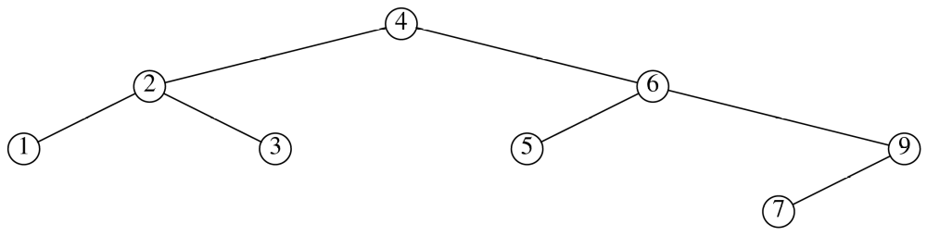
4.20 It is easy to verify by hand that the claim is true for 1 ≤ k ≤ 3. Suppose it is true for k = 1, 2, 3, . . . h. Then after the first 2^{h}−1 insertions, 2^{h−1} is at the root, and the right subtree is a balanced tree containing 2^{h−1} + 1 through 2^{h}−1. Each of the next 2^{h−1} insertions, namely, 2^{h} through 2^{h} + 2^{h−1}−1, insert a new maximum and get placed in the right subtree, eventually forming a perfectly balanced right subtree of height h − 1. This follows by the induction hypothesis because the right subtree may be viewed as being formed from the successive insertion of 2^{h − 1} + 1 through 2^{h} + 2^{h − 1}−1. The next insertion forces an imbalance at the root, and thus a single rotation. It is easy to check that this brings 2^{h} to the root and creates a perfectly balanced left subtree of height h−1. The new key is attached to a perfectly balanced right subtree of height h − 2 as the last node in the right path. Thus the right subtree is exactly as if the nodes 2^{h} + 1 through 2^{h} + 2^{h − 1} were inserted in order. By the inductive hypothesis, the subsequent successive insertion of 2^{h} + 2^{h−1} + 1 through 2^{h + 1}−1 will create a perfectly balanced right subtree of height h − 1. Thus after the last insertion, both the left and the right subtrees are perfectly balanced, and of the same height, so the entire tree of 2^{h + 1}−1 nodes is perfectly balanced (and has height h).

4.21 The two remaining functions are mirror images of the text procedures. Just switch right and left everywhere.
4.22 We will perform post order traversal and compute the height or each subtree as we go. Since the post order traversal runs in linear time, this algorithm runs in linear time.
// Fair refers to heights are correct
bool isFairAndBalanced(BinaryNode<Comparable> *p)
{
if (p == nullptr) return true;
else return (isFairAndBalanced(p->left) && isFairAndBalanced(p->right) &&
((p->left ==nullptr && p->right == nullptr && p->height == 0)||
(p->left==nullptr && p->right->height == 0 && p->height == 1) ||
(p->right == nullptr && p->left->height == 0)&& p->height == 1) ||
(p->height == 1 + max(p->left->height, p->right->height) &&
abs(p->left->height - p->right->height) < 2));
}
4.23 One way to do this is keep a stack of pointers to the nodes visited along the insertion path. using a stack. the pointers can be popped off in reverse order and tested for balance.
template<typename Comparable>
void insert( const Comparable & x, AvlNode * & t )
{
AvlNode<Comparable> * p = t;
stack<AvlNode<Comparable> *> path;
char lastDir;

if ( t== nullptr)
{
t = newAvlNode<Compatable>(x,nullptr,nullptr);
return;
}
while (p != nullptr)
{
path.push(p);
if (x < p->element )
{p = p->left; lastDir = 'l';}
else if (x > p->element)
{p = p->right; lastDir = 'r';}
else if (x == p->element)
return;
}
if (lastDir=='l')
path.top().left= new AvlNode<Compatable>(x,nullptr,nullptr);
else
path.top().right= new AvlNode<Compatable>(x,nullptr,nullptr);
path.pop();
while(!path.empty())
{
balance( path.top());
path.pop();
}
}
4.24 The code in Figure 4.44 implements the AVL deletion algorithm. x is the value to remove, and t is the (sub)tree in question. We recursively traverse down the tree until t matches x, which means we found the appropriate node to delete. The actual deletion occurs in the last two else clauses. There are several cases to consider here. The first case is where t has two children. In this case, as in a binary search tree, we move t's successor node into t's position, and then proceed to remove t's sucessor. The last else clause handles the case where t is a leaf or t has one child. If t is a leaf, then the test t.left != null will be false, and so t is assigned t.right, which is also null. If t has one child, then t is assigned to it. Again, this is how deletion is done in binary search trees. Finally, it is necessary to balance the tree, because a deletion may have temporarily violated the balance (height) requirement of AVL trees.
The code to balance an AVL tree is given in Figure 4.39. It determines whether a single or double rotation is necessary. This balancing code is used for both insertions and deletions. On lines 32 and 38, if the >= is replaced with >, it will have this effect: if the heights of the left.left and left.right children are equal, or the heights of the right.left and right.right children are equal, then we will perform a double instead of single rotation. If we were only dealing with insertions, then it would not make much difference if we used >= or >. Without loss of generality, let us consider the case where an imbalance occurs because height(t.right) - height(t.left) > 1. This imbalance has occurred because we just inserted a new node into the subtree t.right. It cannot be the case that height(t.right.right) equals height(t.right.left). Otherwise, there would be no imbalance at t, or the imbalance was caused on a previous insertion and it was not fixed. This phenomenon was observed in the example in the text after inserting 1-8 in order followed by 16, 15, and 14. The insertions of 15 and 14 cause imbalances necessitating a double rotation.
However, in the case of a deletion, it is possible for height(t.right.right) to equal height(t.right.left). Consider the tree
49
40 60
50 70
The deletion of 40 will cause an imbalance at the 49 node. In this case, a single rotation is appropriate, so we would want a >=, not a >, at line 38 to correctly fix the tree. The case for line 32 with the heights of t.left.left and t.left.right is analogous.
4.25 (a) O(log log N).
(b) The minimum AVL tree of height 127 (8-byte ints range from −128 to 127). This is a huge tree.
4.26 AvlNode doubleRotateWithLeft( AvlNode *k3 )
{
AvlNode *k1, *k2;

k1 = k3->left;
k2 = k1->right;

k1->right = k2->left;
k3->left = k2->right;
k2->left = k1;
k2->right = k3;
k1->height = max( height(k1->left), height(k1->right) ) + 1;
k3->height = max( height(k3->left), height(k3->right) ) + 1;
k2->height = max( k1->height, k3->height ) + 1;

return k3;
}

4.27 After accessing 3,
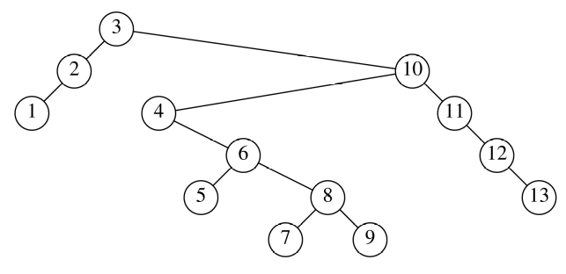
After accessing 9,
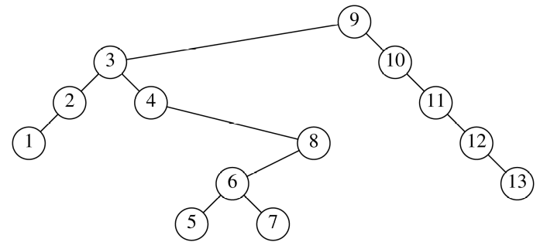
After accessing 1,
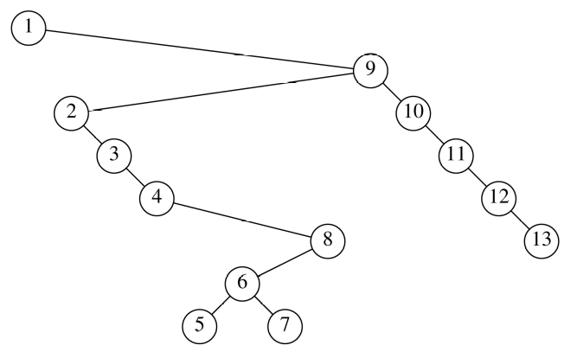
After accessing 5,
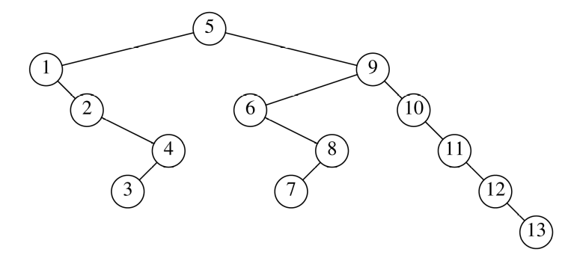

4.28
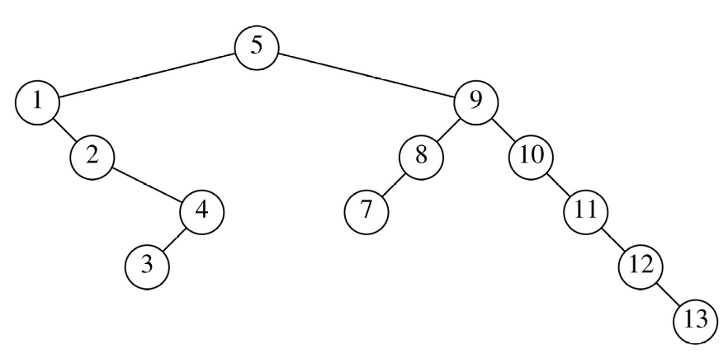
4.29 (a) An easy proof by induction.
4.31 (a-c) All of these routines take linear time.
int countNodes( Node * t )
{
if (t == nullptr)
return 0;
return 1 + countNodes(t->left) + countNodes(t->right);
}

int countLeaves( Node * t )
{
if (t == nullptr)
return 0;
else if ( t->left == nullptr && t->right == nullptr)
return 1;
return countLeaves(t->left) + countLeaves(t->right);
}

int countFull( Node * t )
{
if (t == nullptr)
return 0;
int tIsFull = ( t->left != nullptr && t->right != nullptr)
? 1 : 0;
return tIsFull + countFull(t->left) + countFull(t->right);
}

4.32 Have the recursive routine return a triple that consists of a boolean (whether the tree is a BST) and the minimum and maximum items. Then a tree is a BST if it is empty or both subtrees are (recursively) BSTs, and the value in the node lies between the maximum of the left subtree and the minimum of the right subtrees. Coding details are omitted.

4.33 Node removeLeaves( Node * t )
{
if (t == nullptr || ( t->left == nullptr && t->right == nullptr ))
return nullptr;

t.left = removeLeaves( t.left );
t.right = removeLeaves( t.right );

return t;
}

4.34 We assume the existence of a method randInt (lower, upper) that generates a uniform random integer in the appropriate closed interval.

Node * makeRandomTree( int lower, int upper )
{
Node * t = nullptr;
int randomValue;

if ( lower <= upper )
t = new Node( randomValue = randInt( lower, upper ),
makeRandomTree( lower, randomValue - 1 ),
makeRandomTree( randomValue + 1, upper ) );
return t;
}

Node * makeRandomTree( int n )
{
return makeRandomTree( 1, n );
}

4.35 // LastNode contains last value that was assigned to a node.

Node * genTree( int height, int & lastNode )
{
Node * t = nullptr;

if ( height >= 0 )
{
t = new Node();
t->left = genTree( height - 1, lastNode );
t->element = ++ lastNode[0];
t->right = genTree( height - 2, lastNode );
}
return t;
}

Node * minAvlTree( int h)
{
int lastNodeAssigned = 0;
return genTree( h, lastNodeAssigned );
}

4.36 There are two obvious ways of solving this problem. One way mimics Exercise 4.34 by replacing randInt(lower, upper) with (lower + upper) / 2. This requires computing 2^{h + 1} − 1, which is not that difficult. The other mimics the previous exercise by noting that the heights of the subtrees are both h − 1.

4.37 This is known as one-dimensional range searching. The time is O(K) to perform the inorder traversal, if a significant number of nodes are found, and also proportional to the depth of the tree, if we get to some leaves (for instance, if no nodes are found). Since the average depth is O(log N), this gives an O(K + log N) average bound.

void printRange(Comparable & lower, Comparable & upper, BinaryNode *t)
{
if( t != nullptr )
{
if( lower<= t->element)
printRange( lower, upper, t->left );
if( lower<= t->element && t->element <= upper )
cout<< t->element <<endl;
if( t->element <=upper )
printRange( lower, upper, t->right );
}
}

4.38 This exercise is a likely programming assignments, so we do not provide code here.
4.39 The program below will output the commands Circle(X,Y) and DrawLine(i,j).
const int MAXY= 500;
const int MAXX= 350;
const int RADIUS = 2;

template<typename Comparable>
struct Node
{
Comparable element;
Node<Comparable> *right;
Node<Comparable> *left;
};

template<typename Comparable>
class Tree
{
private:
Node<Comparable> * root;
void drawTree(Node<Comparable> * t, int X, int Y, int delX, int parNum)
{
if (t->right != nullptr)
{
cout<<"Circle("<<X+delX<<","<< Y- 2*RADIUS<<")\n";
cout<<"DrawLine("<<parNum<<","<<parNum+1<<")\n";
drawTree(t->right, X+delX,Y-2*RADIUS, delX/2,parNum+1);
}
if (t->left != nullptr)
{
cout<<"Circle("<<X-delX<<","<< Y- 2*RADIUS<<")\n";
cout<<"DrawLine("<<parNum<<","<<parNum+2<<")\n";
drawTree(t->left, X-delX,Y-2*RADIUS, delX/2,parNum+2);
}
}
public :
void drawTree()
{cout<<"Circle("<<MAXX/2<<","<< MAXY- RADIUS<<")\n";//Draw the root
drawTree(root,MAXX/2, MAXY-RADIUS, MAXX/4, 1);
}
};

4.40 Put the root on an empty queue. Then repeatedly dequeue a node and enqueue its left and right
children (if any) until the queue is empty. This is O(N) because each queue operation is constant
time and there are N enqueue and N dequeue operations.
4.41 The BPlusNode has a parent pointer which makes promoting keys easier. A print function is included for debugging.
#include<iostream>
#include<vector>
#include<algorithm>
using namespace std;

/*
Node for a B+ External/Internal Node
*/
template <typename Comparable>
struct BPlusNode
{
vector<Comparable> keys;
vector<BPlusNode<Comparable> *> pointers;
BPlusNode<Comparable> * parent;
BPlusNode(BPlusNode<Comparable> * p=nullptr) {parent = p;}
};

template <typename Comparable>
class BPlusTree
{
private:
BPlusNode<Comparable> * root;
int maxIn;
int maxEx;
BPlusNode<Comparable> * find(Comparable key, BPlusNode<Comparable> * t)
{
BPlusNode<Comparable> * p;
int i;
if (t == nullptr)
return t;
if (t->pointers.size() == 0) // at leaf node
return t;
else
{
for (i = 0; i < t->keys.size() && key > t->keys[i]; i++);
if (key > *(--(t->keys.end()))) i++;
return find(key, t->pointers[i]);
}
}

void print(BPlusNode<Comparable> * t)
{
if (t != nullptr)
{
for (int i = 0; i< t->keys.size(); i++)
cout<<t->keys[i]<<" ";
cout<<endl;
}
for (int i = 0; i < t->pointers.size(); i++)
print(t->pointers[i]);
}

void promote (Comparable key, BPlusNode<Comparable> * rt,
BPlusNode<Comparable> * p, BPlusNode<Comparable> *n)
{
if (rt == nullptr) // grow the tree
{
root = new BPlusNode<Comparable> ( nullptr);
root -> keys.push_back(key);
root-> pointers.push_back(p);
root->pointers.push_back(n);
n->parent = p->parent = root;
}
else
{
vector <Comparable> tempKeys = rt->keys;
vector <BPlusNode<Comparable> *> tempPtrs = rt->pointers;
int i = 0;
rt->keys.clear();
rt->pointers.clear();
rt->pointers.push_back(tempPtrs[0]);
for ( i = 0; i <tempKeys.size() && key > tempKeys[i]; i++)
{
rt->keys.push_back(tempKeys[i]);
rt->pointers.push_back(tempPtrs[i+1]);
}
rt->keys.push_back(key);
rt->pointers.push_back(n);
for (; i <tempKeys.size(); i++)
{
rt->keys.push_back(tempKeys[i]);
rt->pointers.push_back(tempPtrs[i+1]);
}
if (rt->keys.size() > maxIn) // need to split
{
BPlusNode<Comparable> * newPtr;
newPtr = new BPlusNode<Comparable>(rt->parent);
tempKeys = rt->keys;
tempPtrs = rt->pointers;
rt->keys.clear();
rt->pointers.clear();
for ( i = 0; i < tempKeys.size()/2; i++)
{
rt->keys.push_back(tempKeys[i]);
rt->pointers.push_back(tempPtrs[i]);
}
rt->pointers.push_back(tempPtrs[tempKeys.size()/2]);
for ( i = tempKeys.size()/2 + 1; i < tempKeys.size(); i++)
{
newPtr->keys.push_back(tempKeys[i]);
newPtr->pointers.push_back(tempPtrs[i]);
tempPtrs[i]->parent = newPtr;
}
newPtr->pointers.push_back(tempPtrs[tempKeys.size()]);
promote(tempKeys[tempKeys.size()/2], rt->parent, rt, newPtr);
}// end if to split
}//end else
}// end
void insert(Comparable key, BPlusNode<Comparable> * t)
{
if (root == nullptr)
{
root= new BPlusNode<Comparable>;
root->keys.push_back(key);
return;
}
BPlusNode<Comparable> * ptr = find (key, t);
BPlusNode<Comparable> * newPtr;
vector<Comparable> temp;
ptr->keys.push_back(key);
sort(ptr->keys.begin(), ptr->keys.end());
temp = ptr->keys;
if (ptr->keys.size() > maxEx)
{
// split the node
newPtr = new BPlusNode<Comparable>(ptr->parent);
ptr->keys.clear();
for (int i = 0; i < temp.size(); i++)
if (i < temp.size()/2)
ptr->keys.push_back(temp[i]);
else
newPtr->keys.push_back(temp[i]);
cout<<"promoting "<<temp[temp.size()/2]<<endl;
promote(temp[temp.size()/2], ptr->parent, ptr, newPtr);
}
}
public:
BPlusTree(int in, int ex) {maxIn = in; maxEx = ex; root = nullptr;}
void insert(Comparable key) {insert(key, root);}
void print() {cout<<"Tree:\n"; print(root);}
};

4.43
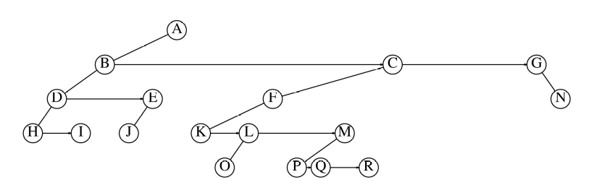
4.44
template<typename Comparable>
struct ChildSibNode
{
Comparable element;
ChildSibNode<Comparable> * child;
ChildSibNode<Comparable> * sib;
};

template<typename Comparable>
void depth1st(ChildSibNode<Comparable> * t)
{
if (t != nullptr)
{
cout<<t->element<<endl;//process the t node
depth1st(t->child);
depth1st(t->sib);
}
}
4.45 The function shown here is clearly a linear time routine because in the worst case it does a traversal
on both t1 and t 2.

bool similar( Node *t1, Node *t2 )
{
if( t1 == nullptr || t2 == nullptr )
return t1 == nullptr && t2 == nullptr;
return similar( t1->left, t2->left ) && similar( t1->right, t2->right );
}
4.46 One can check if two trees are isomorphic by doing a post-order traversal of both trees, and labeling each node with an integer during the traversal.
The algorithm will use a two dimensional array L[i,j], initially with no values assigned; and an integer k, initially set 1.
Whenever you visit a leaf node in the post-order traversal, label it 0.
Whenever you visit any other node n, check the labels of n`’s children.
(We are assuming here that there are always precisely two children, but one can
modify the algorithm to handle the case where this is not true.)
Since this is a post-order traversal, the children already have labels, say i and j with i <= j (I'm not assuming that i is necessarily the label of the left child and j is the label of the
right child). If L[i,j] = m, assign the label m to node n. If L[i,j] is unassigned,
set L[i,j] = k, assign the label k to node n, and increment k.
The two trees will be isomorphic if and only if their roots have the same label.
4.47 The easiest solution is to compute, in linear time, the inorder numbers of the nodes in both trees. If
the inorder number of the root of T₂ is x, then find x in T₁ and rotate it to the root. Recursively apply
this strategy to the left and right subtrees of T₁ (by looking at the values in the root of T₂’s left and right
subtrees). If d_{N} is the depth of x, then the running time satisfies T (N) = T (i) + T (N − i − 1) + d_{N},
where i is the size of the left subtree. In the worst case, dN is always O(N), and i is always 0, so the
worst-case running time is quadratic. Under the plausible assumption that all values of i are equally
likely, then even if d_{N} is always O(N), the average value of T (N) is O(N log N). This is a common recurrence that was already formulated in the chapter and is solved in Chapter 7. Under the more
reasonable assumption that d_{N} is typically logarithmic, then the running time is O(N).

4.48 Add a data member to each node indicating the size of the tree it roots. This allows computation of
its inorder traversal number.

4.49 (a) You need an extra bit for each thread.
(c) You can do tree traversals somewhat easier and without recursion. The disadvantage is that it
reeks of old-style hacking.
4.50 The code below ignores sidebar comments but not /* */ comments. The list of reserved words can be changed according to the interpretation of the problem.
#include <fstream>
#include <cctype>
#include <set>
#include <string>
#include <iostream>
using namespace std;

int main()
{
string line, filename, word;
int pos;
ifstream in;
set<string> idents;
set<string> reserved;
string reserveArray[]= {"for", "if","else", "fstream", "set","string","include", "main", "using", "namespace","std",
"iostream", "string", "ifstream","char","auto","size","open","while","return","int","endl"};
for (int i = 0; i <22; i++)
reserved.insert(reserved.end(),reserveArray[i]);
cout<<"enter the file name: ";
cin>>filename;
in.open(filename.c_str());
getline(in,line);
while (in)
{
pos=line.find("//");
if ( pos < line.size()) // there is a sidebar comment
line = line.substr(0,pos);
for (int i = 0; i < line.size(); i++)
{
if(line[i] =='\'')
{
line[i] =' ';
line[++i]=' ';
line[++i] = ' ';
}
if(line[i] =='"')
{
line[i++] = ' ';
while(i < line.size() && line[i]!='"')
line[i++]= ' ';
}
if (!((toupper(line[i])>='A'&& toupper(line[i])<='Z') || line[i] =='_' ||
(i>0 && toupper(line[i-1])>='A' && toupper(line[i-1]) <='Z'
&& line[i] >='0' && line[i]<='9')))
line[i] = ' ';
}
word = "";
for (int i = 0; i < line.size(); i++)
{
if (line[i] != ' ')
word+=line[i];
else if (reserved.find(word) == reserved.end())
{
idents.insert(word);
word="";
}
else
word = "";
}
getline(in, line);
}
for (auto x:idents)
cout<<x<<endl;
return 0;
}

